# 

# 

# 

# 

# 

# 

# 

# 

# 

# 

# 

**SECTION G5  
TEAM 7**

**SMART CONTRACT PRODUCT (SCP)**

**QUALITY MANAGEMENT PLAN**

# 

# 

# 

# 

# 

# 

# 

# 

# 

# 

# Revision History

|  |  |  |  |
| --- | --- | --- | --- |
| Date | Version | Description | Author |
| 9-3-2019 | 1.0 | Initial write-up | Kenny Kwek, Ong De Lin, Janell Lee, Mark Tan, Lau Jun Rong |
|  |  |  |  |

Table of Contents

**Revision History** **2**

**Quality Assurance** **5**

Introduction 5

Purpose 5

Scope 5

In Scope 5

Out of Scope 5

Quality Objectives 6

Critical-to-Quality 7

Key Performance Indicators (KPI) 7

Quality Management Approach 8

Response Strategy 8

Quality Measures 9

Reviews of all quality-impacting documents 9

Customer Satisfaction 10

Quality Control 10

Testing 11

Non functional tests: 11

Performance & Load testing 11

Usability Testing 12

Configuration Testing 13

Installation Testing 14

Roles and responsibilities 14

IT Operations Manager 14

Quality Assurance 14

Support Manager 15

Tier 1 - Communication, Tier 2 - Business Analyst, Tier 3 - Dev and Infrastructure & Security 15

**Standards and Guidelines** **15**

ITIL framework & CMMi Framework 15

Six Sigma Quality Framework with Kano Analysis 15

ISO 9001 - 7 Quality Management Principles (QMP) 16

Tools 16

Techniques and Methodologies 17

Root Cause Analysis 17

Business Metric 18

IT Infrastructure Metric 18

Configuration Management 19

Risk Management 19

# 

# Quality Assurance

## Introduction

### Purpose

This Quality Management Plan details the overall approach to quality assurance activities for Smart Contract Product project. This Quality Management Plan documents how the project defines, implements and assures quality during the software development process. This Quality Management Plan is a communication vehicle for the entire project team.

### Scope

The scope of this Quality Management Plan, which includes what is in scope and out of scope in the project, will help the team to ensure the quality of the project involving the release of the Smart Contract Product (SCP).

#### In Scope

1. Conduct and monitor regular maintenance
2. Ensure that the quality of the server and web app is met after rollback, maintenance, change and disaster recovery
3. Help determine technology risks on the business
4. Monitor as much as possible as accurately as possible
5. React to all issues found / surfaced
6. Communicate to all stakeholders for problems found
7. Understand the business impact of technical issues
8. Protect the live environment from bad changes
9. Check that business requirements are met
10. Ensure current systems are not degraded
11. Ensure everyone is aware of the change
12. Ensure the change can be supported
13. Ensure no impact on other systems
14. Logging and vetting requirements
15. Perform impact analysis including upstream and downstream systems
16. Interpret performance specifications
17. Ensure traceability of requirements
18. Measure the overall quality of the systems for business purposes
19. Ensure the quality of IT operations

#### Out of Scope

1. Develop maintenance and monitoring tools
2. Calculate the profit and loss of the business using IT systems
3. Define business requirements
4. Generate business requirements
5. Define performance requirements
6. Approve requirement changes
7. Define financials constraints
8. Implementing performance changes
9. Code quality
10. Infrastructure quality

## Quality Objectives

The Quality Objectives for Quality Management in the Smart Contract Product project are to assure that:

* Project deliverables meet their stated requirements.
* Project processes are appropriately followed.

The overall Quality Objectives for Smart Contract Product is to deliver a solution:

1. that is able to create legally binding contracts.
2. that execute legally binding contracts automatically.
3. that displays an embedded link page to a Google Presentation Slides.
4. which can easily handle about 428 connections per second.
5. that has zero downtime during launch week.
6. which has three nines (99.9% availability) during other times.
7. which is able to support at least 50 concurrent users.

### Critical-to-Quality

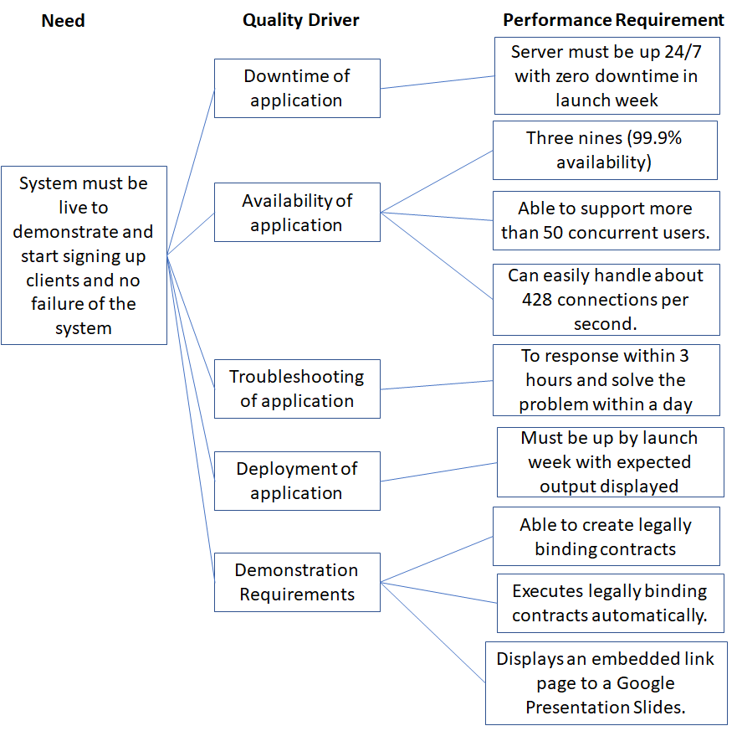

### Key Performance Indicators (KPI)

|  |  |  |  |  |
| --- | --- | --- | --- | --- |
| **S/N** | **Category** | **Key Performance Indicators (KPI)** | **Metric** | **Target** |
| 1 | Deployment / Change | Deployment and Change Frequency   * The speed from which changes in requirements are deployed into production | Days | 3 |
| 2 | Change | Change Success Rate   * The rate at which changes are successfully deployed into production without the need for rollback | Percentage of successful deployment of changes | 100% |
| 3 | Recovery | Mean Time To Detection of Faults   * The time taken for IT support team to discover faults that bring Web App down. | Minutes | 15 |
| 4 | Recovery | Mean Time To Recovery   * The time taken for IT support team to rectify the faults and bring Web App back online. | Hours | 1 |
| 5 | Performance | Service Availability | Availability % | Three nines (99.9%) |
| 6 | Performance | Application Performance | Maximum load tolerance | >= 50- users |
| 7 | Communication | Response Time Between IT support team and Product Managers | Minutes | 5 |
| 8 | Support | Support Ticket Duration   * The length of time from which the ticket is opened by user until it is closed by the agent | Days | 2 |
| 9 | Testing | Status of server under load | Availability % | 100 |
| 10 | Support | Support Ticket Resolution | Percentage | 100 |

## Quality Management Approach

The quality management approach is to ensure that the team "does the right things, right, the first time". Thus avoiding misunderstandings of what to produce and how, resulting in productivity losses, quality losses and schedule delays.

### Response Strategy

Our response strategy entails the following steps:

1. Prevent any problems from the start via quality control testing.
2. Reduce or solve any problems as soon as possible once detected.
3. React swiftly and solve user issues when user complaints arises.
4. Inform relevant stakeholders if there are any impacts towards them due to surfaced issues.

#### Quality Measures

The following are the relevant quantitative and qualitative quality measures our team has decided to check on in order to verify the status of our overall quality.

|  |  |
| --- | --- |
| **Quantitative Measure** | **Plan for measuring quality** |
| No. of Application Processes | * Alert if many application processes are busy for an extended period of time |
| Request Throughput (Requests per second) | * Alert if the number of requests are above the defined threshold |
| Request Processing Time  (in seconds) | * Alert if the request processing time is above the defined threshold |
| Response Data Throughput (In kilobytes per second) | * Alert if the response data transfer speed is above the defined threshold |
| Response Data Processed (In kilobytes per second) | * Alert if the response data processes is above the defined threshold |
| HTTP Errors (No. of HTTP 400 and 500 series errors) | * Alert if the specified HTTP errors to be monitored is above the defined threshold |
| Size of Data sent and retrieved | * Alert if an anomaly in the data volume is sent or retrieved |
| Data Transfer Rate | * Alert if the data transfer speed is not within expected bounds i.e. too slow or fast |
| Data Packet Loss | * Alert if data packet loss is above defined threshold |

|  |  |
| --- | --- |
| **Qualitative Measure** | **Plan for measuring quality** |
| Customer Satisfaction | * Understand overall customer satisfaction through customer feedback tickets posted through the corporate helpdesk website * Conduct survey research on a sample of customers |
| Customer Expectations | * Conduct survey research on a sample of customers |
| Perceived Performance | * Conduct survey research on a sample of customers |

### Reviews of all quality-impacting documents

[Refer to Documentation checklist for all quality-impacting documents](https://drive.google.com/drive/u/1/folders/1MElqJd5q4YRh3bO0CESlsIkqYbUazXsP)

### Customer Satisfaction

To use ISM 214 ESM Ticketing Systems to measure customer satisfaction quantitatively and qualitatively.

|  |  |
| --- | --- |
| **Quantitative Data** | **Qualitative Data** |
| * Number of tickets issued by users & business stakeholder * First Response Time * Duration to resolve tickets * Number of open tickets * Number of resolved tickets | * Content of tickets   + Customer Complaints   + Customer Suggestions |

## Quality Control

The Quality Control in the project focuses on the activities to be conducted to verify that the enterprise solutions are of acceptable quality.

|  |  |  |  |  |
| --- | --- | --- | --- | --- |
| **Activity** | **Description** | **Participants** | **Frequency** | **Documentation** |
| **Project Audit** | Project Audits will be conducted in order to measure the application of the approved Project Plan and discover deviations that can be negative for the project. | IT Operations Manager & Quality Assurance | Annually | Project Audit Report |
| **Quality Audit** | Quality Audits will be conducted in order to measure the application of the approved Quality Plan and discover deviations that can be negative for the project and/or the outcome of the project. | IT Operations Manager & Quality Assurance | Annually | Project Audit Report |
| **Document Review** | *Methodically go through the documents to be examined. They would need to verify the quality of the document, validate the content, identify faults and shortcomings, and to disseminate knowledge of the documents’ content.* | IT Operations Manager & Quality Assurance | Monthly | [Documentation checklist](https://drive.google.com/drive/u/1/folders/1MElqJd5q4YRh3bO0CESlsIkqYbUazXsP) |
| **Project Review** | Project Reviews will be conducted in order to discover any deviations from and/or risks related to time, schedule, scope, and budget which can threaten the project and/or the outcome of the project. | IT Operations Manager & Quality Assurance | Upon request | Project Review Report |
| **Monitoring of server & web app** | Monitoring will be conducted in order to check the status of the application, meeting the business requirements of 99.9% availability. | Tier 1, Tier 2 | Daily | - |
| **Maintenance of server & web app** | Maintenance will be conducted in order to maintain or harden the server & web app. | Tier 3 | Weekly / When necessary | Approval from COO |

### Testing

### Non functional tests:

#### Performance & Load testing

|  |  |
| --- | --- |
| The server can handle 50 concurrent requests   1. Check that siege is installed on lab account’s instance 2. SSH into lab account’s instance 3. Type ‘siege esmscp.tk -c 50’ for 50 users. 4. After 5 to 10 minutes, press Ctrl + C to terminate and see summary. | The server is able to handle the requests with 100% uptime for 50 users. |
| SCP can monitored and is running   1. Go to Nagios Homepage 2. Under the left panel (Current Status), click Services 3. Verify that ClientSCP’s services are up and running (Status is OK and green) |  |

#### Usability Testing

|  |  |
| --- | --- |
| Successful linking of domain name to elastic IP   1. Visit <http://www.esmscp.tk/> 2. Ensure that SCP’s front page loads successfully | Landing page is visible <http://www.esmscp.tk/> |
| The application can display the Google Slides without any errors   1. Clicking ‘play’ will take the user to the next slide 2. Users can toggle between slides 3. Users are able to turn on ‘laser pointer’ mode and ‘fullscreen’ mode |  |
| Successful linking Cloudtopus to AWS instance   1. Visit [https:/www.cloudtopus.com](http://www.cloudtopus.com) and login with SMU Google Account 2. Click on the “Monitor” tab at the front page 3. Verify that Parent Server Status is “Live” 4. Verify that WebApp Status is “Live” | Cloudtopus is able to monitor status of application. |
| Successful setting of AWS Alarms   1. Visit AWS and login to project account “[mark.tan.2017@smu.edu.sg](mailto:mark.tan.2017@smu.edu.sg)” 2. Click on Services > Cloudwatch under Management & Governance 3. Verify that alarms are set on dashboard | Able to affirm that the relevant AWS Alarms have been set and are in operation, by viewing the “Monitoring” panel in the particular instance. |
| Nagios Server is up and can be accessed   1. Go to <http://3.1.98.215/nagios/> 2. Login with nagiosadmin 3. Verify that user can login and see Nagios Homepage |  |
| Valid SSL Certificate   1. Visit <https://www.ssllabs.com/ssltest/> and enter ‘esmscp.tk’ then submit 2. Wait for the test to finish running | The certificate ranking is valid |

#### Configuration Testing

|  |  |
| --- | --- |
| Nginx Server works correctly   1. Access SSH terminal 2. Type “service nginx status” 3. Verify that command outputs “nginx (pid 27083) is running…” to confirm Nginx server has started | Nginx server has started |
| Correct security group settings   1. Visit AWS and login to project account “[mark.tan.2017@smu.edu.sg](mailto:mark.tan.2017@smu.edu.sg)” 2. Click on Security Groups under Network and Security 3. Select group with Group Name of “launch-wizard-1” 4. Click on the inbound tab at the bottom of the screen 5. Visually confirm that security group is correct | Security group has the necessary inbound rules *(HTTP Port 80, SSH Port 22, Custom TCP Rule Port 8000 - 8999 & HTTPS Port 443)* |
| Correct Tags   1. Visit AWS and login to project account “[mark.tan.2017@smu.edu.sg](mailto:mark.tan.2017@smu.edu.sg)” 2. Click on Services > EC2 > Running Instance 3. Select on SCP instance > tags > check that the tags are created | Tags for AWS instance, ‘*Backup = yes, BackupNoReboot = true, BackupRetentionDays = 1*’ has been created for automated AMI backup |

#### Installation Testing

|  |  |
| --- | --- |
| Successful installation of SSL Certificate   1. Visit <https://www.esmscp.tk/> 2. Click on lock icon beside web address 3. Verify that “Connection is secure” is shown in the pop-up | Landing page has SSL Certificate <https://www.esmscp.tk/> |
| Successful installation of htop   1. Access SSH terminal 2. Type “htop --version” 3. Verify that command outputs “htop 1.0.1” to confirm that htop is installed | htop is installed |

## Roles and responsibilities

### IT Operations Manager

The IT Operations Manager is accountable for Quality Management in the project and approves the Quality Plan. To ensure all team members are on the right track to complete the project for critical milestones as well as deadlines.

### 

### Quality Assurance

The role of Quality Assurance reports to the IT Operations Manager and aims to ensure that the deliverables of the project are fit for purpose, is consistent and meets both external and internal requirements. This includes regulatory compliance and customer expectations. Quality Assurance also conducts activities like audits and reviews to ensure that processes and procedures in the project are sufficient for their purpose and are applied and followed.

The role includes responsibility for:

1. Devise and establish the project's quality procedures, standards and specifications.
2. Review project requirements and makes sure they are met.
3. Compile, assess and set standards for quality.
4. Establish and maintain control and documentation procedures.
5. Monitor performance by gathering relevant data and produce quality reports.
6. Make suggestions for changes and improvements and how to implement them.
7. Manage reported deviations from the Quality Plan, either by ensuring that the Quality Plan is followed, or through a Change Request adapting the Quality Plan to better reflect the reality of the project.

### Support Manager

The Support Manager will work with the Quality Assurance to compile and customize Quality Objectives and Standards, ensure compliance with those standards, and to report deviations and needs for changes to the Quality Assurance.

### Tier 1 - Communication, Tier 2 - Business Analyst, Tier 3 - Dev and Infrastructure & Security

Although the Quality Assurance is responsible for Quality Management of the project, all project members are responsible to follow the Quality Plan and report directly to Support Manager or the Quality Assurance when one considers that the quality plan deviates from reality, or that it is not followed.

### 

## 

# **Standards and Guidelines**

### ITIL framework & CMMi Framework

1. [Process Description using ITIL & CMMi Frameworks](https://docs.google.com/document/d/122Xc-Kbk7i7v3VDbZgpSuDw_htSNfQhecD05ZYDRVqE/edit)
2. [Incident Management Documentation using ITIL](https://docs.google.com/document/d/1mnK4CZVHuO0sc_VCkj6X-witxJilXwUmPqShce1X5ss/edit)
3. [Change Management Description using ITIL](https://docs.google.com/document/d/1SOXM7iEo9b4OaCJ8wgZDYXhLM-nkJxXeRoTWIKlJMgs/edit#heading=h.xb3h03bzd02b)

### Six Sigma Quality Framework with Kano Analysis

|  |  |
| --- | --- |
| **Quality** | **Description** |
| **Expected** | 1. Three nines (99.9% availability) 2. Must be up by launch week with expected output displayed 3. App must be working and usable 4. Minimal loading time to the website 5. Can easily handle about 428 connections per second. 6. able to support more than 50 concurrent users. |
| **Desired** | 1. Server must be up 24/7 with zero downtime in launch week |
| **Excited** | To response within 3 hours and solve the problem within a day |

### ISO 9001 - 7 Quality Management Principles (QMP)

|  |  |
| --- | --- |
| **QMP1 – Customer Focus** | * Ensure that customer’s requirements are of our team’s main focus. * Communication with customers must be consistent throughout the process * Customer’s needs is always top priority |
| **QMP2 – Leadership Importance of Top Management** | * Ensure top management is aware of implementation of any form of quality management through emails to COO * Any changes to quality management should be approved or with the knowledge of COO |
| **QMP3 – Engagement of People** | * Engagement of employees allow them to see the value in the system * Assign metrics to employees for them to monitor and take necessary corrective actions |
| **QMP4 – The Process Approach** | * Focusing efforts on predictable and individual processes of the system * Metrics are developed based on different categories |
| **QMP5 – Improvement** | * Ensure improvements in quality to react to changes and create new opportunities * Take necessary measures when KPIs/metrics fall below the target |
| **QMP6 – Evidence-based decision making** | * Ensure decisions made are based on analysis and evaluation of data * Maintenance of records to ensure integrity and availability of data for decision making |
| **QMP7 – Relationship Management** | * Management of stakeholders’ relationships(customers, suppliers) to ensure successful impact on the company |

## Tools

|  |  |
| --- | --- |
| **Tools** | **Description** |
| **Nagios** | 1. Ability to monitor server’s Disk Usage, SSH Service, HTTP and PING |
| **Cloudtopus** | 1. Ability to monitor server & web app status 2. Ability to monitor average CPU utilization & average network packets in tracking |
| **AWS Cloudwatch** | 1. Ability to monitor server with different statistics such as CPU Utilization Average, Disk Read Bytes Average, Network Packets In Average and others. 2. Ability to set up customized alarms when server hits a set threshold. |
| **Siege** | 1. Ability to test whether the server is load-balanced by simulating load into the server 2. Ability to show results of simulation (displaying any abnormalities and status of server) |
| **Documentation Checklist** | 1. Assists Quality Assurance & IT Operations Manager when they methodically go through the documents to be examined 2. Ensure that all quality-impacting documents are not missed |
| **IS214 ESM Ticketing System** | 1. Ability to manage tickets issued by users & business stakeholders 2. Can also be used to check for time taken to resolve tickets (Check against CTQ) |

## Techniques and Methodologies

### Root Cause Analysis

|  |  |  |  |  |  |  |
| --- | --- | --- | --- | --- | --- | --- |
| **Issue #** | **Issue Description** | **Cause Description** | **Root Issue** | **Issue Category** | **Business measure impacted** | **Impact level** |
| 1 | Long loading time to enter website | Server is unable to handle load of many concurrent users | Server is not load balanced properly | System | Loading time of website | High |
| 2 | Port down | Server cannot be accessed by port number | Possible DDoS attack | System | 1. Application Performance 2. Service Availability | High |
| 3 | Server is down and not running | Server cannot be accessed entirely | Instance down | System | Application Performance | High |
| 4 | Website does not show expected output | Website is loaded with different output from the server | Incorrect or buggy code deployed | System | Application Performance | Medium |
| 5 | Change deployment failed | Change code failed to produce correct output | Incorrect or buggy code deployed | System | Change Success Rate | Medium |

### Business Metric

|  |  |  |
| --- | --- | --- |
| **Element** | **Description** | **Response** |
| Application Processes | Busy and idle process metrics | WARNING if too many are busy for too long |
| Request Throughput | Request throughput (requests per second) | WARNING if above a defined threshold |
| Request Processing Time | Request processing time, in seconds | WARNING if too long |
| Response Data Throughput | Response data throughput, in KB per second | WARNING if above a defined threshold |
| Response Data Processed | Response data processed, in KB per second | WARNING if above a defined threshold |
| HTTP Errors | Number of HTTP 4xx and 5xx errors | WARNING if above a defined threshold |

### IT Infrastructure Metric

|  |  |  |
| --- | --- | --- |
| **Element** | **Description** | **Response** |
| CPU Usage | CPU usage and idle times | WARNING if high for extended period |
| Memory Usage | Memory usage and free memory, in MB | WARNING if high for extended period |
| Active HTTP Connections | Number of active HTTP connections | WARNING if above a defined threshold |
| Connection Duration | Length of time for connections | WARNING if above a defined threshold |

## Configuration Management

[Configuration Management for SCP Build 1.0.0](https://docs.google.com/document/d/1FZ65dyBPsci7Ki9NH4rBkGSKJy4UT7F_sSRBv3cIu40/edit#heading=h.nhb47kayvoye)

## Risk Management

[Risks for Managing Quality](https://docs.google.com/document/d/18pL5zTottFJKjpy0Vcxzb8WTbU7dsctpDczkQ7QwOao/edit)